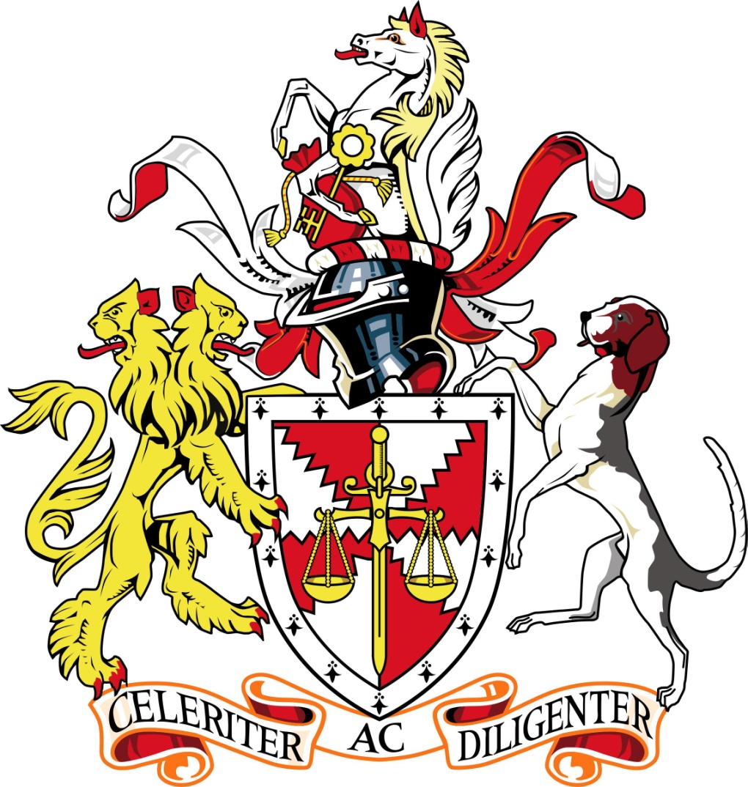
Call for Papers for First Annual Writing Competition
Chartered Institute of Arbitrators
North American Branch
Young Members Group

- Statement of Purpose

Sponsored by the Young Members Group (YMG) of the North America Branch (NAB) of the Chartered Institute of Arbitrators (CIArb), the Annual Writing Competition (Competition) seeks to create greater interest in the field of international arbitration among young practitioners, law students, and researchers, while further developing the field with fresh perspectives.

- Eligibility

The Competition is open to all young practitioners and law students within the geographic scope of CIArb NAB, which includes the entirety of Mexico and the United States (except for New York, New Jersey, and Connecticut). Participants must meet the following requirements:

  - “Young practitioners” are defined as individuals admitted to practice law in a jurisdiction within the geographic scope of the CIArb NAB and who are under the age of 40 as of December 31, 2020.

  - “law students” are defined as full and part-time students who currently are pursuing or who obtained within 6 months prior to January 1, 2020 a JD, LLB, LLM, PhD, S.J.D, or J.S.D at a law school accredited within the geographic scope of the CIArb NAB.

- Subject Matter and Length of Submissions

The submission may address any aspect of international arbitration practice, theory, or research. Submissions must be written in English and between 7,500-12,500 words (including footnotes). Submissions must also include an abstract of no more than 150 words.

The author must include on a cover page his or her name and other identifying information, such as his or her law school or professional institution.

- Authorship, Originality, and Prior Publication

Each entry shall be the original work of a single individual. The ideas and work reflected by each entry must be the author’s own. Co-authored submissions will not be accepted.

Previously published submissions are not eligible.

- Entry Procedures

The submission should be submitted to writingcompetition@CIArbNAB.com. The e-mail should have the subject header “Writing Competition.” Submissions must be sent in an MS Word or compatible format (“.doc” or “.docx”). The Competition will confirm receipt of all submissions.

Submissions must be received by May 31, 2020 at 11:59 PM EST.

- Judging

The Competition is intended to stimulate creativity of thought and research. Entries will be judged based on the following criteria: (1) significance of the topic to the field of international arbitration; (2) originality and creativity of topic; (3) quality of analysis, research, and authority; and (4) technical quality of writing, including organization, grammar, syntax, and form.

Entries will be judged anonymously. The Competition reserves the right not to award any prize if it determines that no entries are of sufficient quality to merit selection.

- Prize

The winner of the Competition will receive: (1) a $2,500.00 honorarium from CIArb NAB; and (2) complimentary registration to the CIArb NAB Tech ADR Summit & Annual Conference at Microsoft World Headquarters in Seattle, Washington on October 1, 2020.

The winning submission also will be given priority consideration for publication in the International Journal of Arbitration, Mediation and Dispute Management.

